Web data extraction Requirement document

Suggested Code Policy:

1. Copy the Project folder structure from bellow github link.

<https://github.com/hackathonScrapping/BANK.git>

1. Use Python(Mandatory) with BeautifulSoup, Scrapy and Selenium (Feel free to use any other Python libraries)
2. Store Scrapped data with provided file name and CSV format.

Work 1:

**Scarped Data Format (File Name - SUNTRUST_Data_Deposit_<MM_DD_YYYY>.csv)**

|  |  |  |  |  |  |  |  |  |  |
| --- | --- | --- | --- | --- | --- | --- | --- | --- | --- |
| Date | Bank Name | Product Name | Minimum Opening Balance | Minimum Daily Balance |  | Minimum Balance | Maximum Balance | Interest Rate | APY |
|  |  |  |  |  |  |  |  |  |  |
|  |  |  |  |  |  |  |  |  |  |
|  |  |  |  |  |  |  |  |  |  |
|  |  |  |  |  |  |  |  |  |  |
|  |  |  |  |  |  |  |  |  |  |
|  |  |  |  |  |  |  |  |  |  |

|  |  |  |  |  |  |  |  |  |  |  |  |  |
| --- | --- | --- | --- | --- | --- | --- | --- | --- | --- | --- | --- | --- |
|  |  | |  |  |  |  |  |  | | | |  |
|  |  | |  |  |  |  |  |  | | | |  |
|  | |  | | | | | | | | | |  |
|  |  | |  |  |  | | | |  |  |  |  |

**Steps**

1. Click on below bank site

<https://www.suntrust.com/personal-banking/savings-accounts>

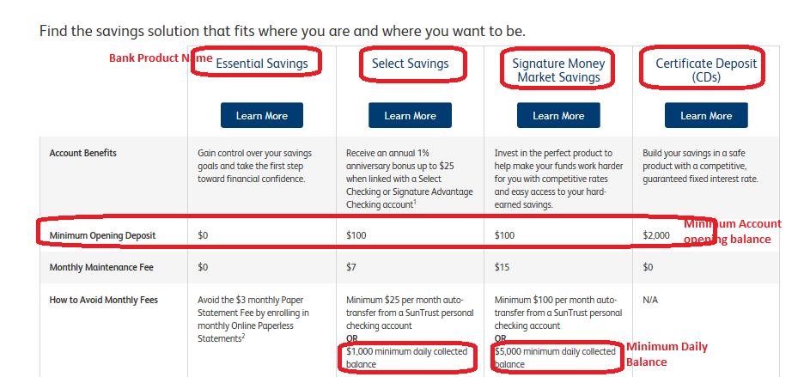

Click on Select Savings

<https://www.suntrust.com/personal-banking/savings-accounts/select-savings>

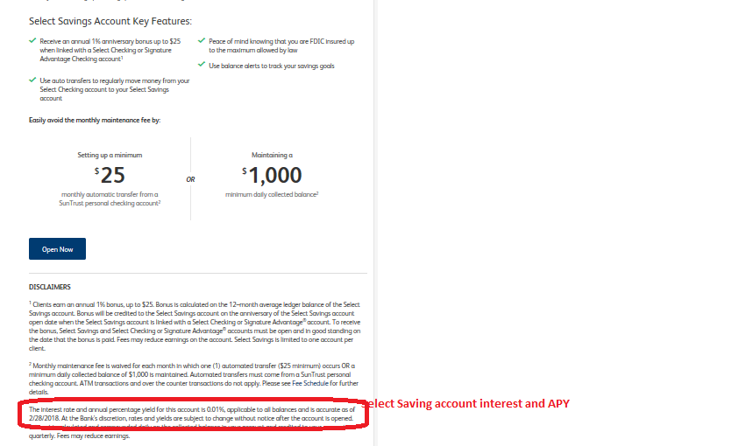

Click on Signature Money Market Savings

<https://www.suntrust.com/personal-banking/savings-accounts/signature-money-market-savings>

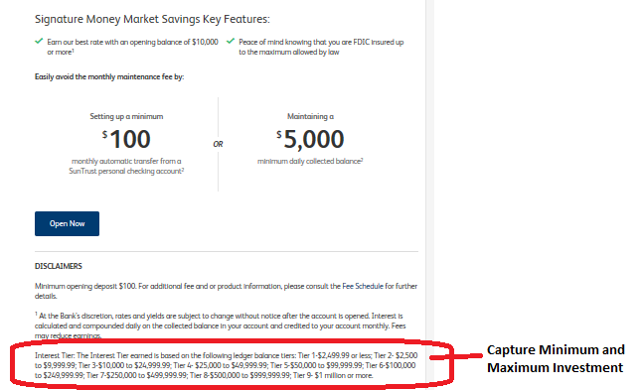

Click on Certificate Deposit (CDs)

<https://www.suntrust.com/personal-banking/savings-accounts/cds>

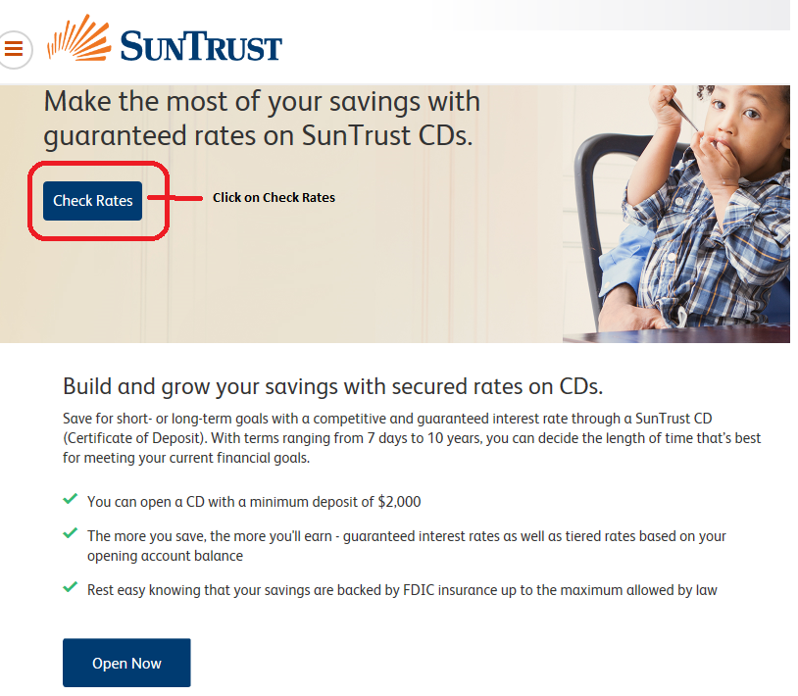

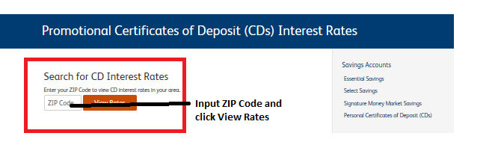

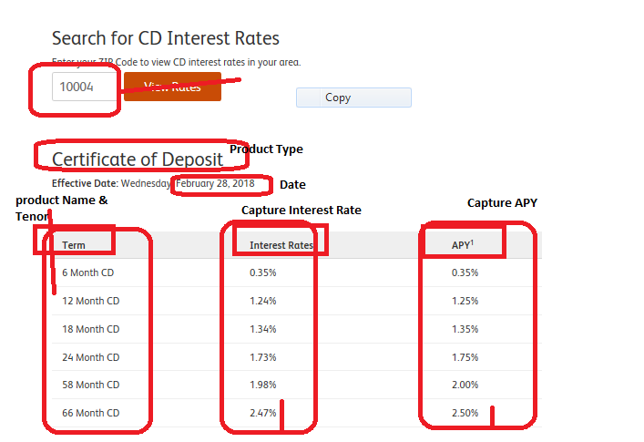

<https://www.suntrust.com/personal-banking/checking>

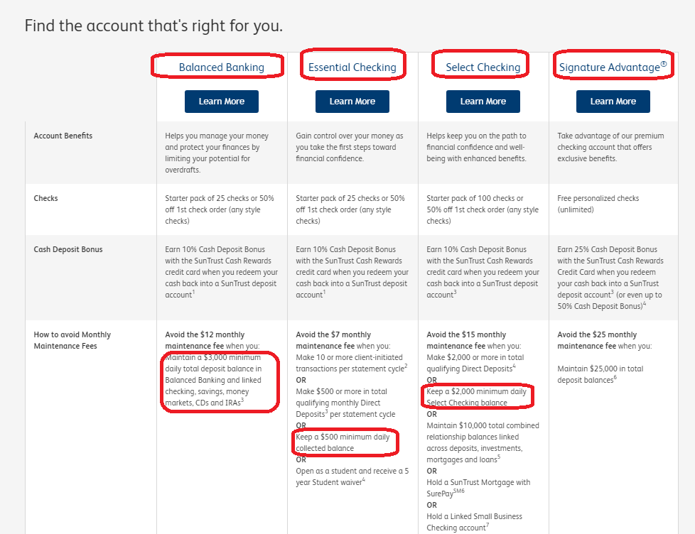

<https://www.suntrust.com/personal-banking/checking/select-checking>

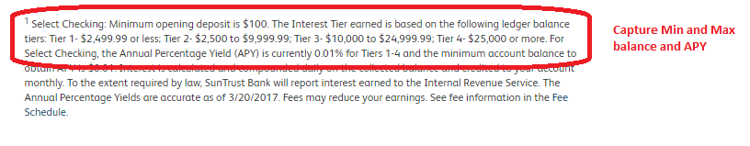

<https://www.suntrust.com/personal-banking/checking/signature-advantage-checking>

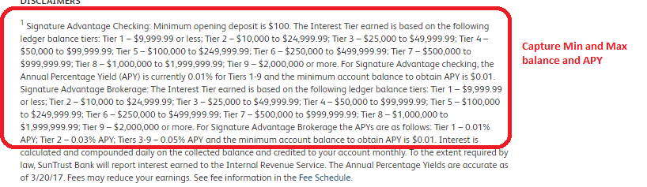

|  |  |
| --- | --- |
| Work 2: Capturing Mortgage data  URL: <https://www.suntrust.com/home-mortgages/current-rates>**D:\Personal\Ramesh\BlackPool\Requirement Docs\Snapshot\ST01.png**  **D:\Personal\Ramesh\BlackPool\Requirement Docs\Snapshot\ST02.png**  **D:\Personal\Ramesh\BlackPool\Requirement Docs\Snapshot\ST04.pngD:\Personal\Ramesh\BlackPool\Requirement Docs\Snapshot\ST03.png** |  |

**Please capture only top row interest rates (ignore 2nd and more rows)**